

|  |
| --- |
| **GSC – Time Entry System** |

**Technical Documentation**

Author: Nievha Ellainne Sia

September 10, 2015

Confidential

# Copyright

Copyright © 2011 Gurango Software Corporation

All rights reserved.

Information in this document is prepared by Gurango Software Corporation for improving the Time entry system to help the organization for registering and tracking employee attendance, it can integrate with existing payroll and human resource systems, as well as various collection devices. It can also help the project manager track the progress of the projects. The software described in this document is furnished under a license agreement or nondisclosure agreement. The software may be used or copied only in accordance with the terms of those agreements. No part of this document may be reproduced, stored in a retrieval system, or transmitted in any form or by any means without the prior written permission of the company.

**Gurango Software Corporation**

Units 7-8 G/F Topy's Place Building,

Industria cor. Economia St.,

Barangay Bagumbayan, Libis, Quezon City

Philippines 1110

Telephone: + 63 (2) 637-0928

Facsimile : + 63 (2) 636-3800

www.gurango.com

# Revision

Change Record

|  |  |  |  |  |
| --- | --- | --- | --- | --- |
| **Version** | **Date** | **Location of Change** | **A**  **M**  **D** | **Detailed Description of Change [Author]** |
|  |  |  |  |  |
|  |  |  |  |  |
|  |  |  |  |  |
|  |  |  |  |  |
|  |  |  |  |  |
|  |  |  |  |  |
|  |  |  |  |  |
|  |  |  |  |  |
|  |  |  |  |  |
|  |  |  |  |  |

*A = Added M = Modified D = Deleted

**Client Review**

|  |  |  |  |  |
| --- | --- | --- | --- | --- |
| **Name** | **Position** | **Version Approved** | **Remarks** | **Date** |
|  |  |  |  |  |
|  |  |  |  |  |
|  |  |  |  |  |
|  |  |  |  |  |
|  |  |  |  |  |
|  |  |  |  |  |
|  |  |  |  |  |
|  |  |  |  |  |
|  |  |  |  |  |
|  |  |  |  |  |

# Table of Contents

Copyright 2

Revision 3

Table of Contents 4

1. Introduction 5

1.1. Project Background 5

1.2. Project Objective 5

1.3. Document Description 5

1.4. Assumptions and Constraints 6

1.5. Abbreviations and Definition of Terms 6

1.6. Points of Contacts 6

2. Time Entry System Overview 7

3. Functional Requirements 8

3.1. Process Overview 8

3.2. Guidelines 9

3.3. Page Events 10

3.4. User Interface 11

3.4.1. Log in 11

3.4.2. Time Entry System for Staff 12

3.4.3. Adding Record 13

3.4.4. Time Entry System for Project Manager 15

3.4.5. Time Entry System for Validating Staff Entries (PM) 16

3.4.6. Time Entry System for Timekeeper 17

3.4.7. Time Entry System for Validating Staff Entries (Timekeeper) 18

4. Views and Reports 19

5. Sign-off 20

# Introduction

## Project Background

In the previous time entry system that Gurango Software Corporation use is the Daily Activity Report (DAR). Time Entry System is a time-tracking program by recording when, for how long and what activities are performed. This was the second wave of the daily record system. The idea is for the project manager to get the actual picture about how many hours per week the employee spent to do a certain project. The new Time Entry System is support the user of the system by allowing the staff and project managers to input all their daily activities. Also the project managers as the immediate approver for the time entries of their staff if there is any correction that requires a detail modification. PM may add, remove, search, view employee information or designation information and more. Time keeper has the access in all the inputted entries to validate records concerning the billability of the project.

## Project Objective

In order to produce good customer relationships, the company needs to establish their performance objectives. The iterative process involving the performance of their employees, understanding and documenting the current workload of their employees. Time Entry System is software that helps organization for registering and tracking employee attendance, it can integrate with existing payroll and human resource systems, as well as various collection devices. The main purpose of this project is to critically assess the weekly workload of each employee and to track the progress of the project. The company needs a tool that can store and process the essential data to make adjustments in reducing or eliminating the problems present within the existing system. This document describes the scope of the Time Entry System solution.

## Document Description

The Blueprint is the start in developing the system and is a collaborative effort between all business and technology stakeholders. This document provides a general description of the requirements in developing the Time Entry System. It is not meant to be an exhaustive explanation of how these configurations are to be performed.

The objective of this document is only to define the scope of the software development activities. Furthermore, the Blueprint:

* Forms the basis of planning
* Forms the basis of quality assurance; and
* Forms the basis of functional tests

It is further understood that the intent of this document is to identify and describe the functions, customized or native in Time Entry System that are essential or critical upon implementation. The non-critical functions are considered on a case-by-case basis once end-users have become more familiar with the features found in the Time Entry System.

## Assumptions and Constraints

1. The infrastructure and hardware wherein to deploy the Time Entry System (TES) should be available.
2. Scheduled notifications and events estimates are based on generic list followed for standard implementation
3. List of legacy system fields that need to be mapped to Time Entry System (TES) will be provided to GSC
4. Creation of non-standard reports/non-statutory reports are not included in defined estimates
5. Services are subject to the terms and conditions of the GSC standard Consulting Agreement and Service Order
6. Service estimates do not include integration to any software not provided by GSC
7. Services estimates assume the implementation of the standard GSC product, any customizations or modifications are subject to additional charges.

## Abbreviations and Definition of Terms

|  |  |
| --- | --- |
| **ABBREVIATIONS OF TERMS** | **DESCRIPTION** |
| TES | Time Entry System |
| GSC | Gurango Software Corporation |
| PM | Project Manager |

## Points of Contacts

Below is a complete list of individuals associated with the CRM project:

|  |  |
| --- | --- |
| **NAME** | **ROLE** |
| Stephen Villavert | Technical Business Unit Head, Gurango Software Corporation |
| Nievha Sia | Functional Consultant, Gurango Software Corporation |
| Joseph Cadiao | Software Developer, Gurango Software Corporation |
| Justine Tio | Project Coordinator/Timekeeper, Gurango Software Corporation |

# Time Entry System Overview

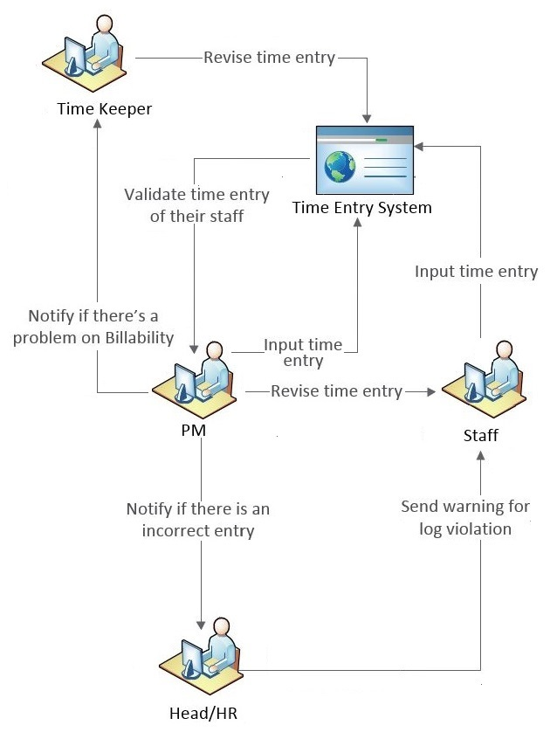

# Functional Requirements

This section present the process flows for the Time Entry System (TES) user interface, forms and process flows.

## Process Overview

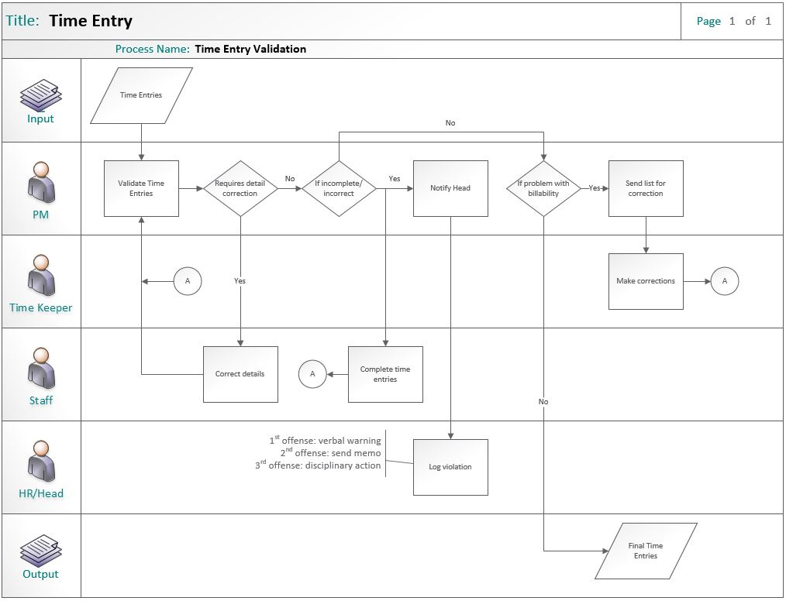

Figure. 3.1. Time Entry Validation

## Guidelines

Here are some guidelines in creating your records.

1. Every Project is considered as one record/row for your activity. If you have an activities where you have the same Project, but with different Activity Type, Staff Type, Billability, or On Site, that'll still be considered as another Unique Record.
2. You can also add/delete row/s to save simultaneously your activities. Note: Maximum entry per save is 10 records/row only.
3. By checking the checkbox of specific row in the 'Select' column in editing table, you can manage to delete that row.
4. Empty Activity Description field, causes failure to save your entry. So, always give a precise description for every activity you are recording.
5. Time rendered for each activity per day is recorded under the columns of Days of Week. Whitespace on this fields, automatically set by the system to 'zero' (0). Also non-negative and non-numeric are restricted for input.
6. After filling all the necessary or required (with red asterisk) fields, kindly double check all the information you supply to every field, especially the billability type of the activity. Finally, you can now save your entry.
7. Once the record is created, you can no longer delete it, rather you can edit its content.

## Page Events

In this section you can familiarize yourself to different events that can occur while creating your entry.

* **Supplying Weeknumber**
  + Previous weeknumber, disables the editing table together with buttons - Cancel, Save, Add Row, Delete
  + Enables you to view the records in that week with the current year
* **Previous(<) />Next(>) Button**
  + Enables you to go to previous/next week per click
  + Enables you to view the records in the week specified in the textbox with the current year
* **Cancel Button**
  + Resets the whole page to its initial state
* **Save Button**
  + Saves all the rows within the editing table and resets the whole page to its initial state
* **Add Row Button**
  + Creates empty additional row in the editing table
* **Delete Button**
  + Deletes selected row
* **All Records Link Button**
  + Enables you to view all your entries.
  + Additional column 'Created On' for the date and time of creation of the entry
  + Also, clicking this sets the moth-date header in record table to '#####', to signify that you are viewing records regardless the date time
  + To go back to weekly view of records, you can simply press (<) or (>) buttons.

## User Interface

### Log in

|  |  |  |  |  |  |  |  |  |  |
| --- | --- | --- | --- | --- | --- | --- | --- | --- | --- |
|  |  | | |  |  |  |  | | |
| DESCRIPTION: | This form is used to enter new daily or weekly task in a certain project. | | | | | | | | |
| PATH: | <http://dar:3004/Login> | | | | | | | **NEW:** | ☑ |
|  | | | | | | | | | |
| OBJECT NAME | **TYPE** | **FIELD REQUIREMENT** | **DEFAULT or POSSIBLE VALUES** | **DESCRIPTION** | | | | | |
| Time Entry System | | | | | | | | | |
| Username | Text | Required |  | Text field to enter username | | | | | |
| Password | Text | Required |  | Text field to type the user’s password | | | | | |

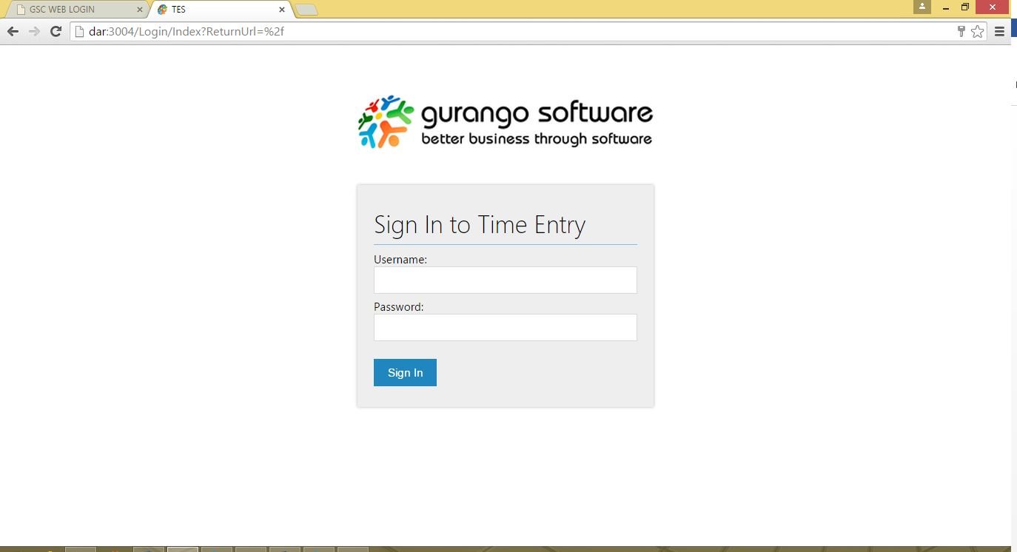

Figure. 3.4.1. Sign In to Time Entry

### Time Entry System for Staff

|  |  |  |  |  |  |  |  |  |  |
| --- | --- | --- | --- | --- | --- | --- | --- | --- | --- |
|  |  | | |  |  |  |  | | |
| DESCRIPTION: | This form is used to enter new daily or weekly task in a certain project. | | | | | | | | |
| PATH: | <http://dar:3004/Login> > Sign In | | | | | | | **NEW:** | ☑ |
|  | | | | | | | | | |
| OBJECT NAME | **TYPE** | **FIELD REQUIREMENT** | **DEFAULT or POSSIBLE VALUES** | **DESCRIPTION** | | | | | |
| Time Entry System | | | | | | | | | |
| Previous button | Button | Optional |  | Shows the previous week. | | | | | |
| Search box | Text | Optional |  | Enable the user to search or jump in to the desired date/week. | | | | | |
| Search button | Button | Optional |  | Trigger button to search for the desired date/week. | | | | | |
| Next button | Button | Optional |  | Button to show the next week | | | | | |
| Add record button | Button | Optional |  | Allows the user to enter activities done for the week. | | | | | |
| Search box | Text | Optional |  | Allows the user to search for the desired project name, activity name, role, or practice name. | | | | | |
| Dropdown button | Dropdown | Optional |  | Allows the user to choose the desired view. | | | | | |

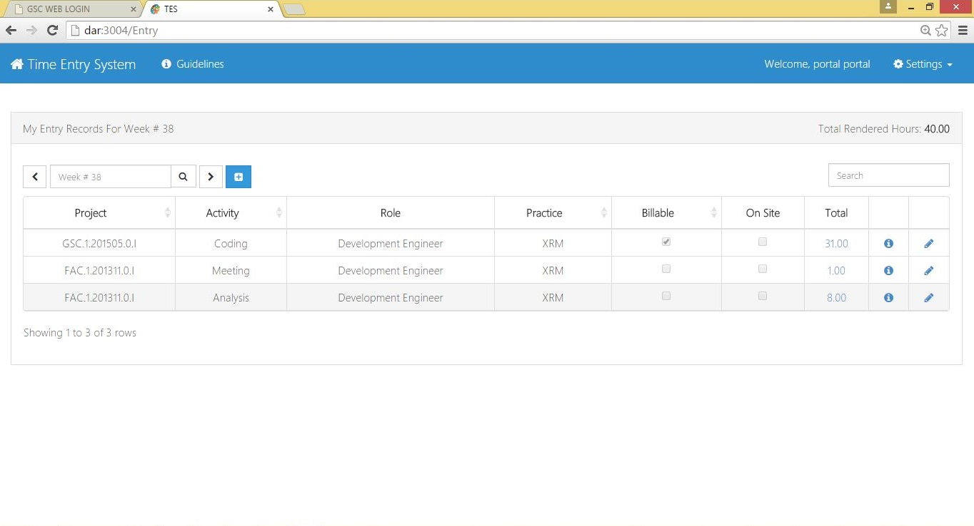

Figure. 3.4.2. Time Entry System

### Adding Record

|  |  |  |  |  |  |  |  |  |  |  |
| --- | --- | --- | --- | --- | --- | --- | --- | --- | --- | --- |
|  |  | | |  |  |  | |  | | |
| DESCRIPTION: | This form is used to enter new daily or weekly task in a certain project. | | | | | | | | |
| PATH: | <http://dar:3004/Login> > Sign In > Add Record | | | | | | **NEW:** | | ☑ |
|  | | | | | | | | | |
| OBJECT NAME | **TYPE** | **FIELD REQUIREMENT** | **DEFAULT or POSSIBLE VALUES** | **DESCRIPTION** | | | | | |
| Activity Description | | | | | | | | | |
| Project | Drop down | Required |  | Shows the list of projects. | | | | | |
| Role | Drop down | Required | Project Manager, Functional Consultant, Development Engineer, Technology Consultant, Human Resource Associate | Shows the list of role or staff type. | | | | | |
| Activity | Drop down | Required | Coding, Analysis, Meeting, Holiday | Shows the type of activity assigned to the user. | | | | | |
| Practice | Drop down | Required | XRM, DHCM, DMS | Shows the type of practice assigned to the user. | | | | | |
| Billable | Check box | Optional |  | Check if the activity related to the project is billable. | | | | | |
| On Site | Check box | Optional |  | Check if the activity done is on site. | | | | | |
| Description | Text | Required |  | Text field to indicate some additional information to describe the activity. Minimum of length of 10 and maximum length of 250. | | | | | |
| Hours Rendered | | | | | | | | | |
| Number of hour | Number | Optional |  | To input the number of hours rendered on the project. | | | | | |

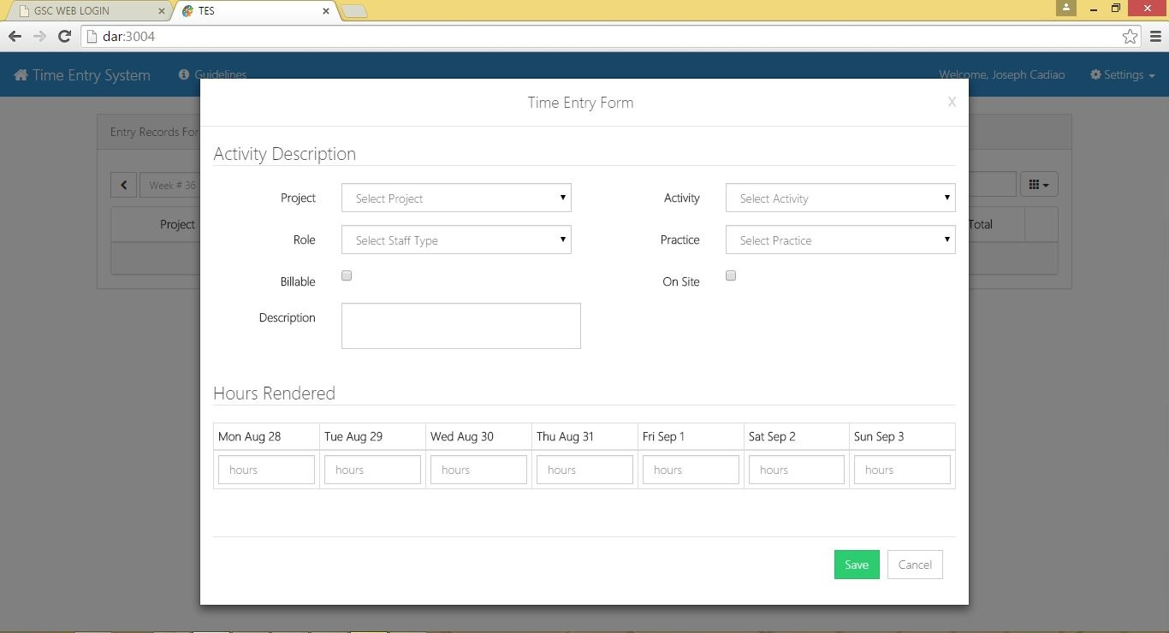Figure. 3.4.3. Adding Record Form

### Time Entry System for Project Manager

|  |  |  |  |  |  |  |  |  |  |
| --- | --- | --- | --- | --- | --- | --- | --- | --- | --- |
|  |  | | |  |  |  |  | | |
| DESCRIPTION: | This form is used to enter new daily or weekly task in a certain project. | | | | | | | | |
| PATH: | <http://dar:3004/Login> > Sign In | | | | | | | **NEW:** | ☑ |
|  | | | | | | | | | |
| OBJECT NAME | **TYPE** | **FIELD REQUIREMENT** | **DEFAULT or POSSIBLE VALUES** | **DESCRIPTION** | | | | | |
| Time Entry System | | | | | | | | | |
| Previous button | Button | Optional |  | Shows the previous week. | | | | | |
| Search box | Text | Optional |  | Enable the user to search or jump in to the desired date/week. | | | | | |
| Search button | Button | Optional |  | Trigger button to search for the desired date/week. | | | | | |
| Next button | Button | Optional |  | Button to show the next week | | | | | |
| Add record button | Button | Optional |  | Allows the user to enter activities done for the week. | | | | | |
| Search box | Text | Optional |  | Allows the user to search for the desired project name, activity name, role, or practice name. | | | | | |
| Dropdown button | Dropdown | Optional |  | Allows the user to choose the desired view. | | | | | |

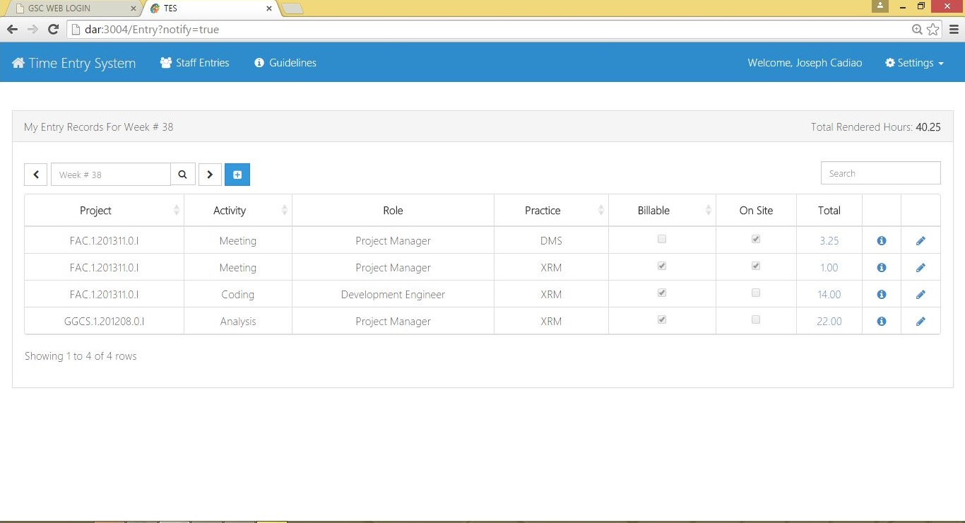

Figure. 3.4.4. Time Entry System

### Time Entry System for Validating Staff Entries (PM)

|  |  |  |  |  |  |  |  |  |  |
| --- | --- | --- | --- | --- | --- | --- | --- | --- | --- |
|  |  | | |  |  |  |  | | |
| DESCRIPTION: | This form is used to enter new daily or weekly task in a certain project. | | | | | | | | |
| PATH: | <http://dar:3004/Login> > Sign In > Staff Entries | | | | | | | **NEW:** | ☑ |
|  | | | | | | | | | |
| OBJECT NAME | **TYPE** | **FIELD REQUIREMENT** | **DEFAULT or POSSIBLE VALUES** | **DESCRIPTION** | | | | | |
| Time Entry System | | | | | | | | | |
| Previous button | Button | Optional |  | Shows the previous week. | | | | | |
| Search box | Text | Optional |  | Enable the user to search or jump in to the desired date/week. | | | | | |
| Search button | Button | Optional |  | Trigger button to search for the desired date/week. | | | | | |
| Next button | Button | Optional |  | Button to show the next week | | | | | |
| Add record button | Button | Optional |  | Allows the user to enter activities done for the week. | | | | | |
| Search box | Text | Optional |  | Allows the user to search for the desired project name, activity name, role, or practice name. | | | | | |
| Dropdown button | Dropdown | Optional |  | Allows the user to choose the desired view. | | | | | |
| Staff Entries | List | Optional |  | List of staff entries is displayed | | | | | |
| Flag Staff | Button | Optional |  | Button to flag staff for entry revision | | | | | |
| Flag Timekeeper | Button | Optional |  | Button to flag timekeeper for billability concern | | | | | |
| Confirm Valid | Button | Optional |  | Button to confirm valid | | | | | |
| Close | Button | Optional |  | Button to close | | | | | |

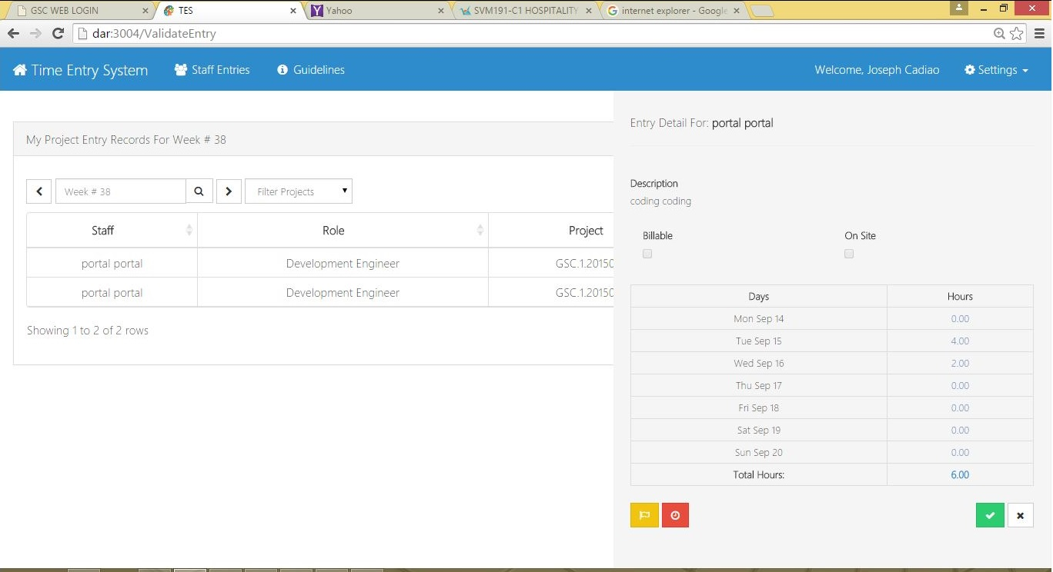

Figure. 3.4.5. Time Entry System

### Time Entry System for Timekeeper

|  |  |  |  |  |  |  |  |  |  |
| --- | --- | --- | --- | --- | --- | --- | --- | --- | --- |
|  |  | | |  |  |  |  | | |
| DESCRIPTION: | This form is used to enter new daily or weekly task in a certain project. | | | | | | | | |
| PATH: | <http://dar:3004/Login> > Sign In | | | | | | | **NEW:** | ☑ |
|  | | | | | | | | | |
| OBJECT NAME | **TYPE** | **FIELD REQUIREMENT** | **DEFAULT or POSSIBLE VALUES** | **DESCRIPTION** | | | | | |
| Time Entry System | | | | | | | | | |
| Previous button | Button | Optional |  | Shows the previous week. | | | | | |
| Search box | Text | Optional |  | Enable the user to search or jump in to the desired date/week. | | | | | |
| Search button | Button | Optional |  | Trigger button to search for the desired date/week. | | | | | |
| Next button | Button | Optional |  | Button to show the next week | | | | | |
| Add record button | Button | Optional |  | Allows the user to enter activities done for the week. | | | | | |
| Search box | Text | Optional |  | Allows the user to search for the desired project name, activity name, role, or practice name. | | | | | |
| Dropdown button | Dropdown | Optional |  | Allows the user to choose the desired view. | | | | | |

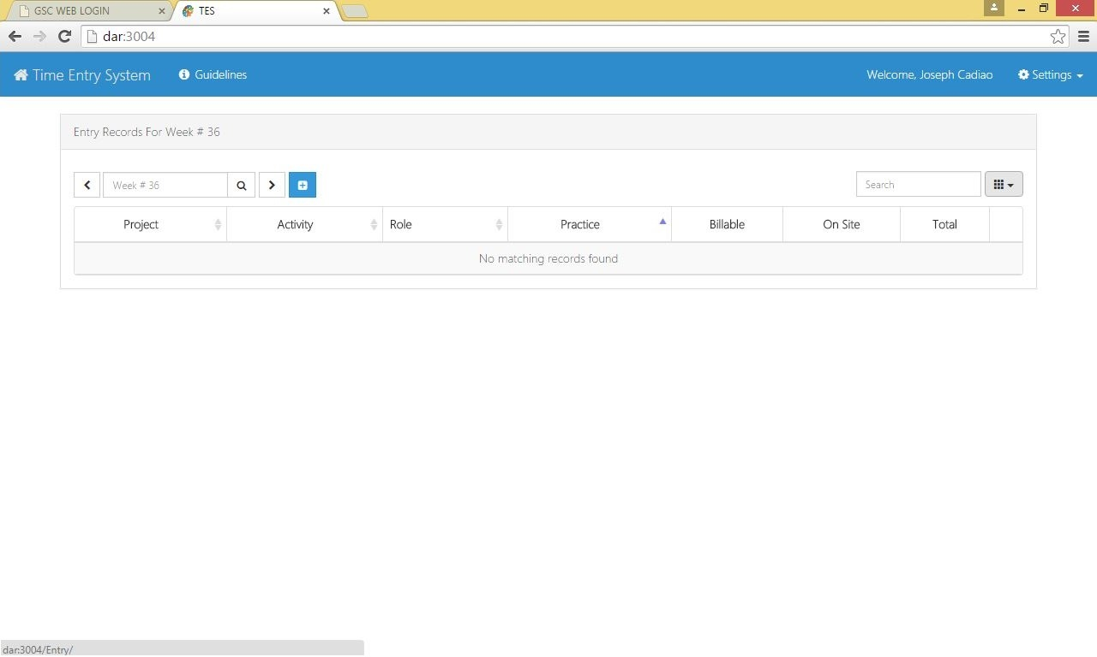

Figure. 3.4.6. Time Entry System

### Time Entry System for Validating Staff Entries (Timekeeper)

|  |  |  |  |  |  |  |  |  |  |
| --- | --- | --- | --- | --- | --- | --- | --- | --- | --- |
|  |  | | |  |  |  |  | | |
| DESCRIPTION: | This form is used to enter new daily or weekly task in a certain project. | | | | | | | | |
| PATH: | <http://dar:3004/Login> > Sign In > Time keeping | | | | | | | **NEW:** | ☑ |
|  | | | | | | | | | |
| OBJECT NAME | **TYPE** | **FIELD REQUIREMENT** | **DEFAULT or POSSIBLE VALUES** | **DESCRIPTION** | | | | | |
| Time Entry System | | | | | | | | | |
| Previous button | Button | Optional |  | Shows the previous week. | | | | | |
| Search box | Text | Optional |  | Enable the user to search or jump in to the desired date/week. | | | | | |
| Search button | Button | Optional |  | Trigger button to search for the desired date/week. | | | | | |
| Next button | Button | Optional |  | Button to show the next week | | | | | |
| Add record button | Button | Optional |  | Allows the user to enter activities done for the week. | | | | | |
| Search box | Text | Optional |  | Allows the user to search for the desired project name, activity name, role, or practice name. | | | | | |
| Dropdown button | Dropdown | Optional |  | Allows the user to choose the desired view. | | | | | |
| Flagged Staff Entries | List | Optional |  | List of Flagged staff entries is displayed | | | | | |
| Billable | Check box | Optional |  | Revise check/uncheck activity related to the project. | | | | | |

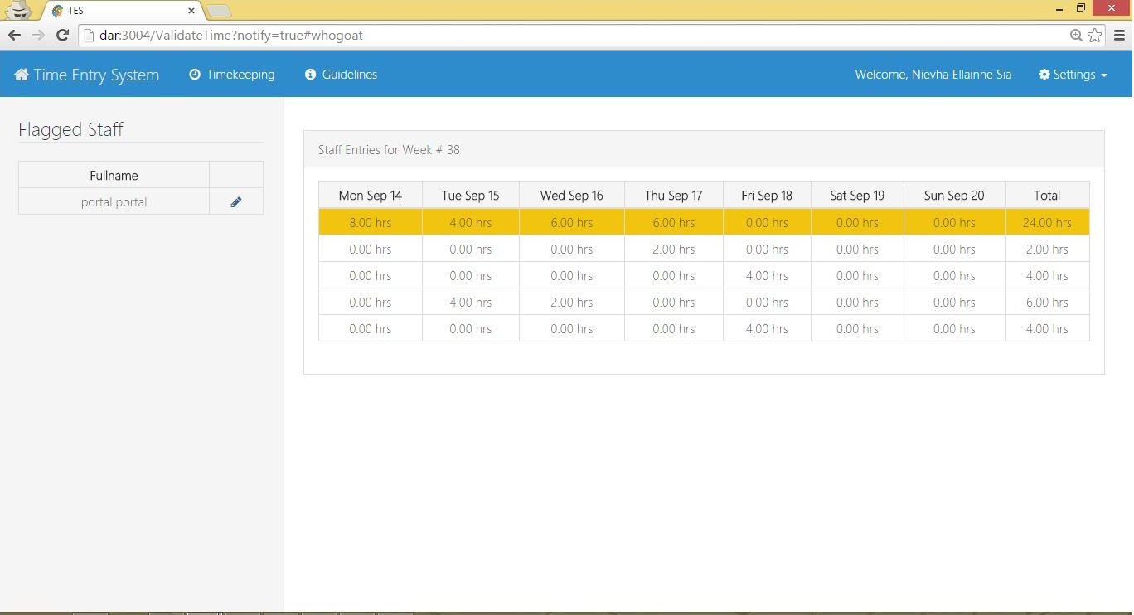

Figure. 3.4.7. Time Entry System

# Views and Reports

Presented in this chapter are the views and reports. The contents, format and lay-out of the dashboard, views and reports is dependent on the data and entities as define in Chapter 3 – Functional Requirements. A separate blueprint for the dashboards, views and reports is to be prepared and signed-off before development. Time Entry System comes with 25 out-of-box reports for viewing your business data. The following table shows a list of available reports and what data they get when you run.

# Sign-off

I agree that this document constitutes an accurate description of the scope of work that I am expecting for this project.

I understand that further changes to the forms, workflows and reports will likely result in a delay in the final delivery date and could result in additional costs.

|  |  |  |  |
| --- | --- | --- | --- |
| **Vendor:** | | | |
| Name | Project Role | Signature | Date Signed |
| Nievha Ellainne Sia | Functional Consultant |  |  |
| Joseph Cadiao | Software Developer |  |  |
| **Recommending Approval:** | | | |
| Name | Project Role | Signature | Date Signed |
| Stephen Villavert | Technical Business Unit Head |  |  |
| Justine Tio | Project Coordinator/ Timekeeper |  |  |
| **Final Approval:** | | | |
| Name | Project Role | Signature | Date Signed |
| Berlly Oliver Castillo | Service Delivery Manager |  |  |
| Rafael Ladios | Functional Service Unit Head |  |  |